Creating a Pipeline job in Jenkins

Launch EC2-Instance(Ubuntu):

In this example I have used Ubuntu operating system.

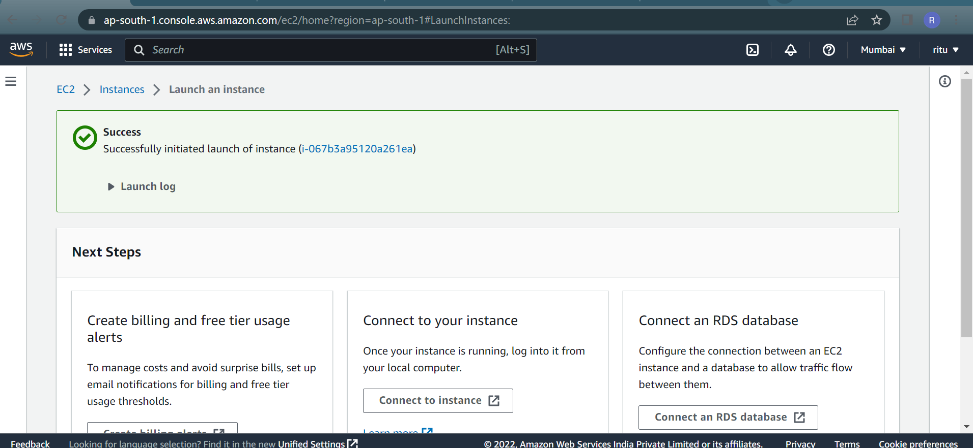

Make sure Instance is in running state

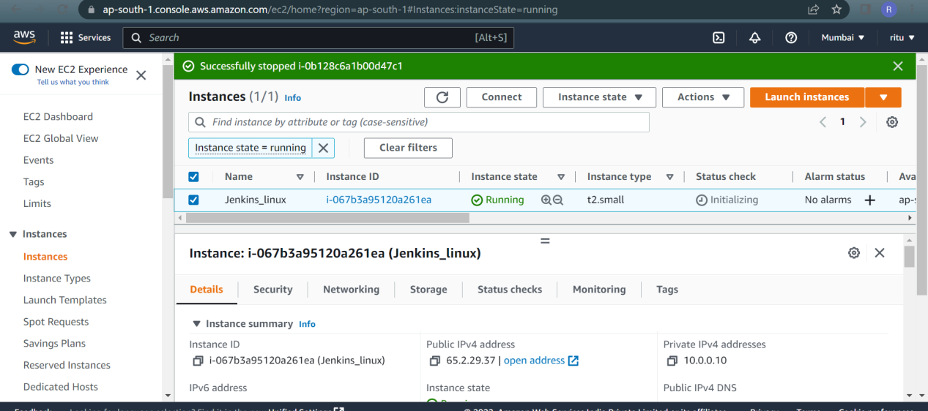

Connect to instance:
Open an SSH client and locate your keypair file(*.pem). In my case I have Linux-keypair.pem
Connect to your instance using your public ip
Use the below command to ssh into your instance
# ssh -i /path/key-pair-name.pem instance-user-name@instance-public-dns-name
Now we are able to ssh into EC2-Instance

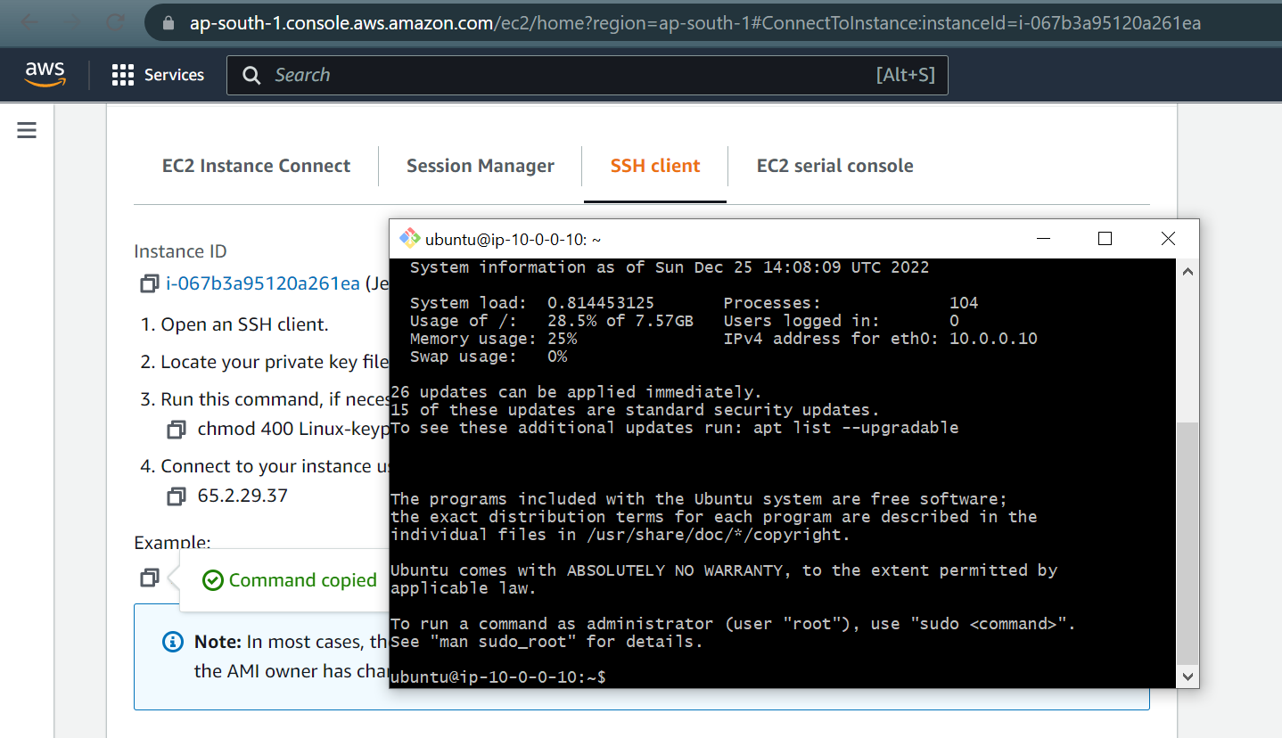

Jenkins login:
Now sue your public IP in any of the web browser to access jenkins UI.
It might look like this

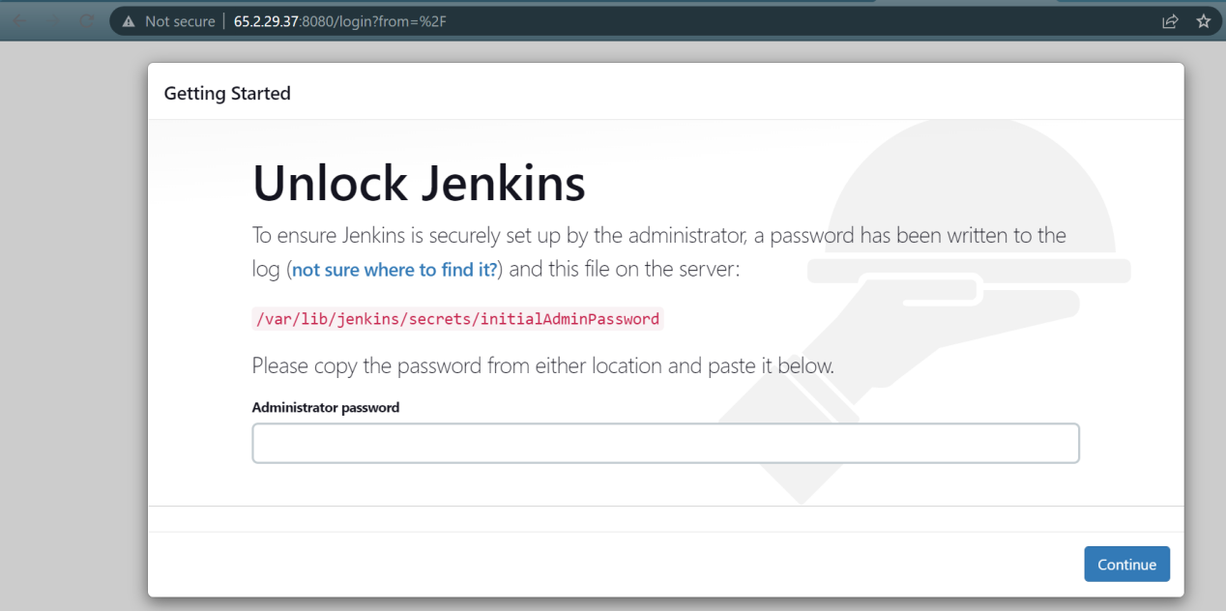

Setup username and Password for Jenkins:

To create users in Jenkins first we need to unlock jenkins.
Go to /var/lib/jenkins/secrets/initialAdminPassword from jenkins server and use this password to unlock jenkins

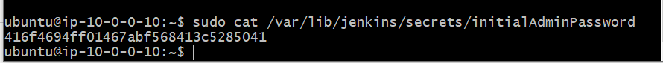

Next we can see Getting Started Page,here we can install necessary plugins or we can do it later.By default Jenkins add some plugins automatically.

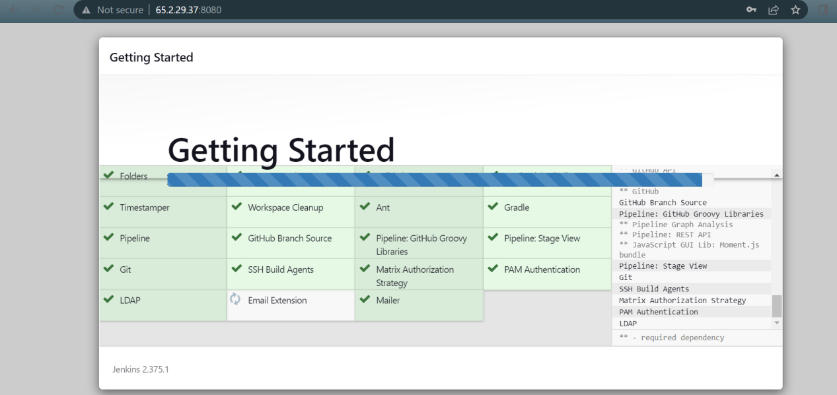

Now create user and password for your Jenkins server.

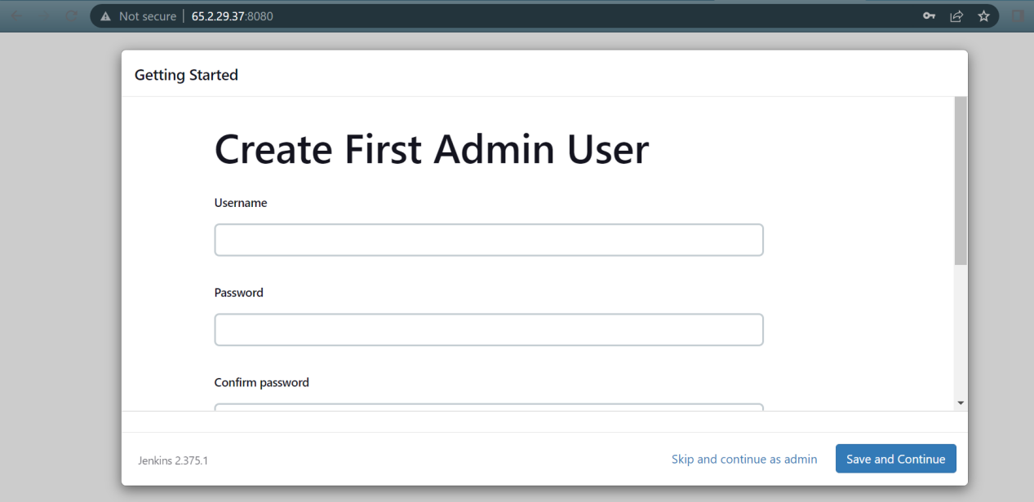

Jenkins is ready to use!

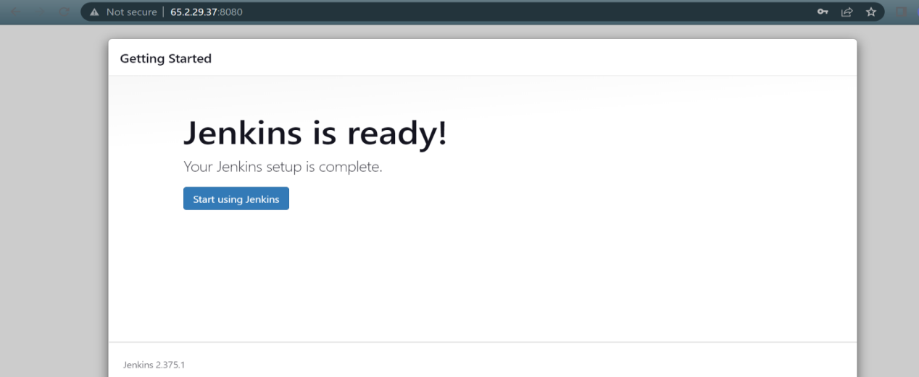

Create Job in Jenkins :

Go to Dashbaord > New item
Give some logical name to your Job and select Pipeline

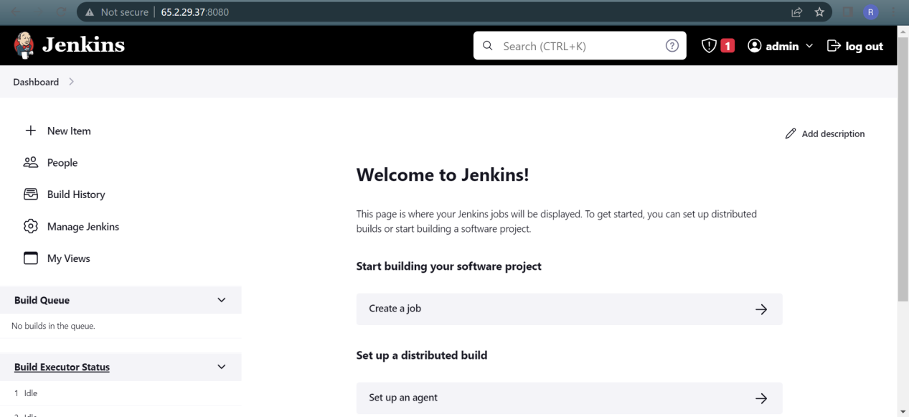

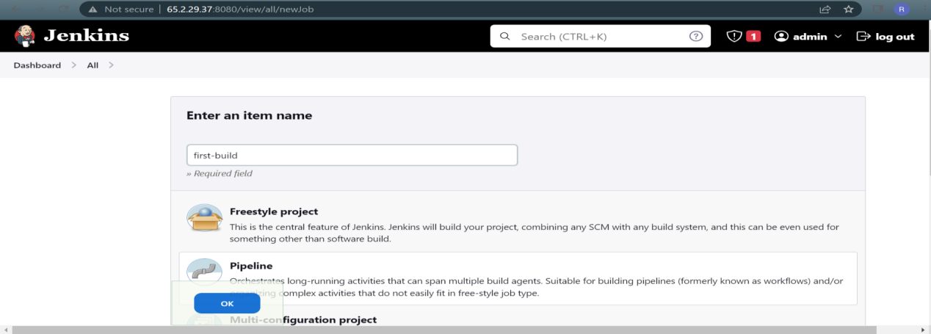

Adding GitHub Project URL

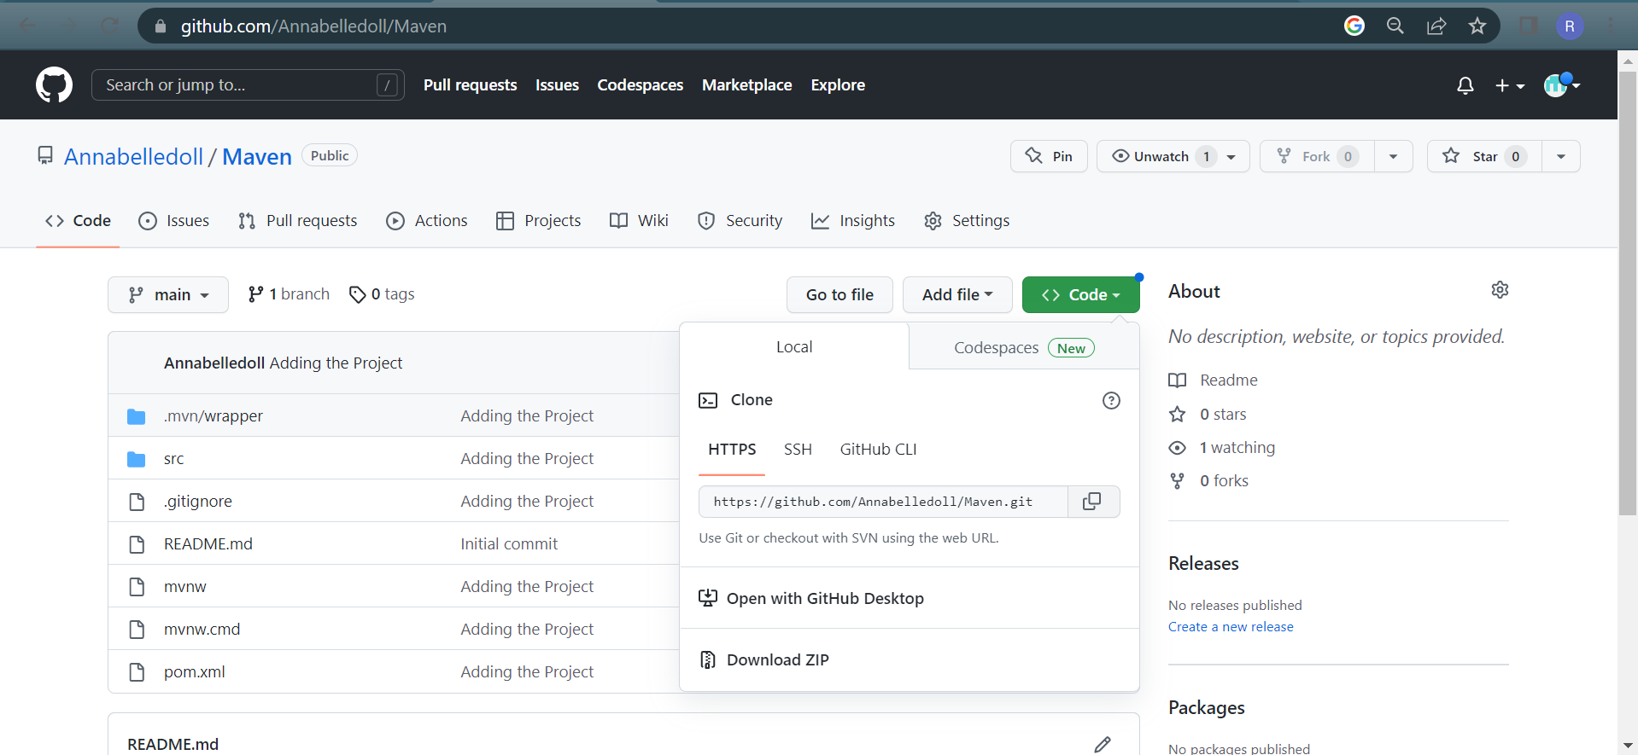

I have written below pipeline script to print Hello world.
This Pipeline script includes taking project from git and uses maven as build tool.

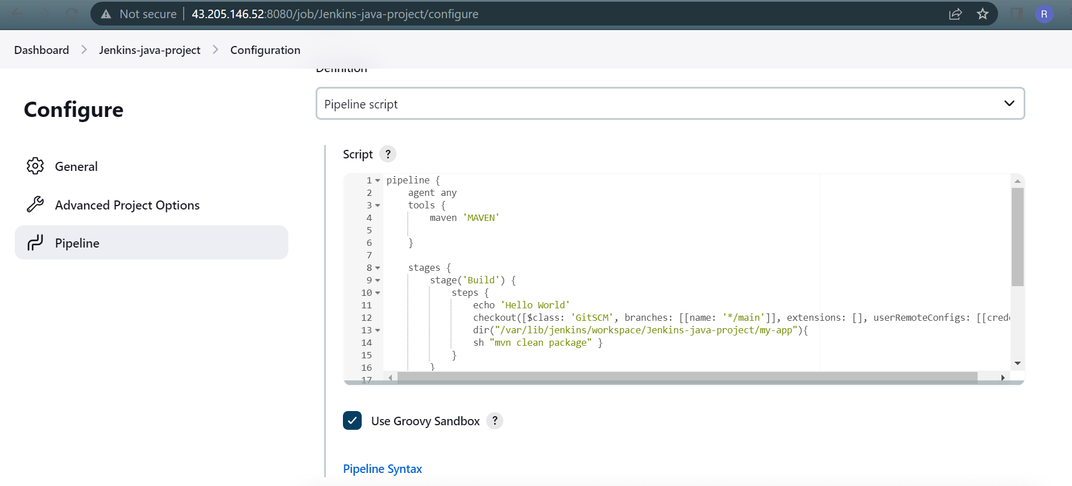

Output:

Finally the Build is successful.

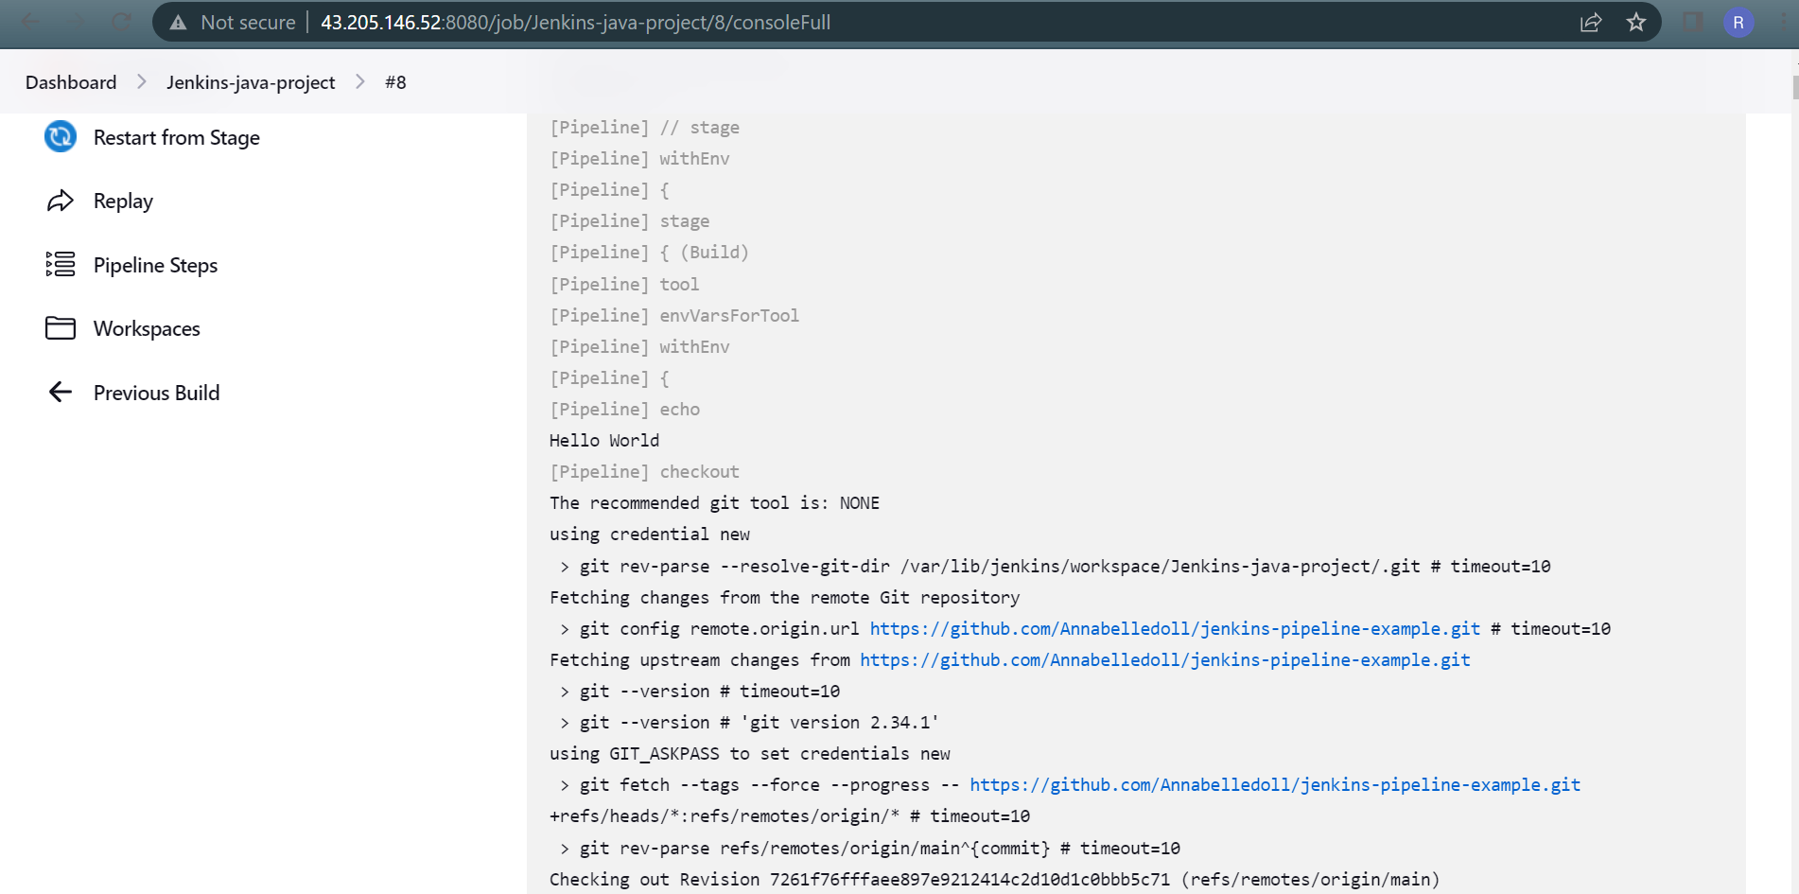

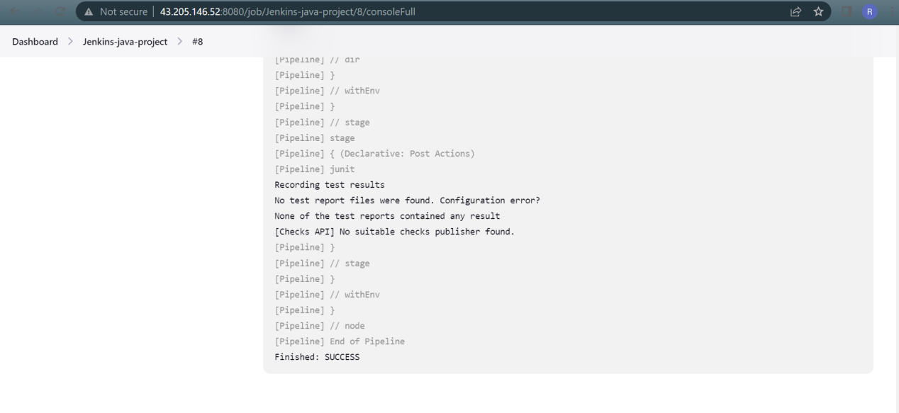

Thank you

